|  |  |
| --- | --- |
| \\VFILERDPI\DPI-Home\OBRIENR2\My Documents\Downloads\PP logo.jpg | Central Coast Council Logo |
| **MEMO TO PANEL**  HUNTER AND CENTRAL COAST REGIONAL PLANNING PANEL | |

|  |  |
| --- | --- |
| PANEL REFERENCE & DA NUMBER | PPSHCC -87  DA/1163/2021 |
| PROPOSAL | Redevelopment of fire damaged Registered Club and associated parking, landscaping and other works |
| ADDRESS | 2-4 Park Road, The Entrance, Lot 1 DP 180642, Lot 1 DP 406038,  10 Warrigal Street, The Entrance, Lot 50 DP 661107 |
| APPLICANT | Mingara Leisure Group C/- ADW Johnson Pty Ltd |
| OWNER | Central Coast Council (2-4 Park Road) &  Mingara Recreation Club Ltd (10 Warrigal Street) |
| REGIONALLY SIGNIFICANT CRITERIA | Clause 3(b) Schedule 6 of the SEPP (Planning Systems) 2021. Council owned land with CIV exceeding $5 million |
| CIV | $9,663,059 (excluding GST) |
| RECOMMENDATION | Deferred Commencement Consent |
| SCHEDULED MEETING DATE | 20 July 2022 |
| PREPARED BY | Principal Development Planner – Salli Pendergast |

**MATTERS RAISED**

DA/1163/2021 seeks approval for redevelopment of the existing fire damaged club and associated parking landscaping and other works.

Please find below response to the matters raised by the Panel in their meeting held 20 July 2022.

* **Revised and updated draft conditions**

Attached are revised and updated draft recommended conditions to reflect the discussions held at the Panel meeting of 20 July 2022. The changes to the condition include:

* Extension of the timeframe for satisfaction of the deferred commencement from 6 months to 12 months (but not to 24 months)
* Deletion of the deferred commencement condition 3 in relation to the plinth signage
* Removal of unnecessary or duplicated conditions.
* Revision and combining of the various signage conditions
* Inclusion of new and revised conditions to address the above matters including acoustic measures, LED signage illumination, reference to earlier consent for parking on other lots and tree protection.
* ***Acoustic***

The Panel had raised concerns regarding the potential acoustic impacts to the residential properties adjoining the existing car park at 10 Warrigal Street.

Council’s Senior Environmental Protection Officer has further assessed this matter and has advised:

*Further consideration has been given to the Amended Acoustic Assessment by PKA Acoustics Consulting (D15015489) that was prepared on behalf of the applicant.*

*Although not restrictive to the progression of this application, it has been noticed that the acoustic assessment did not adequately consider a worst case scenario where the existing carpark situated at 10 Warrigal Street The Entrance would be utilised in a high use capacity. Therefore, it is recommended that an additional condition be applied with the intent of protecting the local amenity on the adjoining properties by constructing an adequately sized acoustic fence.*

The following recommended condition is included in the revised draft conditions.

*X An acoustic fence must be constructed at a minimum height of 1.8m along the adjoining property of 12 Warrigal Street, 1 Benelong Street & 3 Benelong Street The Entrance. The acoustic fence must be of solid timber construction that has double lapped boards, of 15mm thickness and a continuous thickness of 30mm along the entirety of the fence.*

Further wording has been included with this condition to ensure the protection of the existing trees in the vicinity of the fencing works.

* ***LED signage***

At the Panel meeting, the applicant has requested the deletion of draft deferred commencement condition 3 requiring a reduction in the size of the proposed LED signage.

In response to hearing the applicant discuss their concerns regarding the deferred commencement condition, the Panel has requested additional information be provided regarding the acceptable illumination levels for the LED sign during night time within a residential context.

Under Section 3.3.3 and Table 6 (page 46) of the Transport Corridor Outdoor Advertising and Signage Guidelines 2017, there are 4 different zones that can apply for digital advertisements as follows:

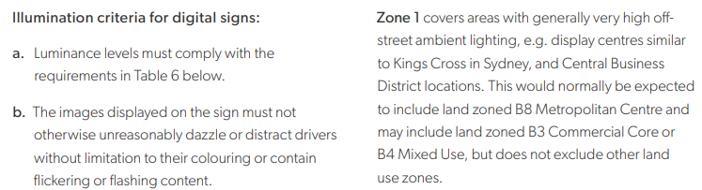

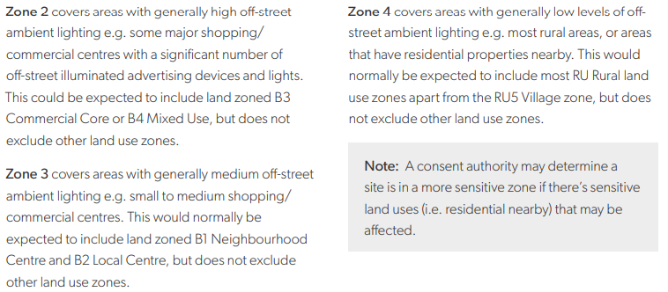

The applicant was requested to demonstrate how their expert had concluded in their submitted report that Zone 3 was applicable (under the *Transport Corridor Outdoor Advertising and Signage Guidelines 2017)* rather than Zone 4 given that the site is predominantly surrounded by residential, rather than commercial land uses. In this regard, Zone 4 has a more restrictive maximum illuminance.

In response, the applicant has further advised:

*It has been assessed that the proposed LED sign is located in Zone 3 of the aforementioned requirements/guidelines which covers areas with generally medium off-street ambient lighting e.g. small to medium shopping/commercial centres. It was noted that The Greens Bowling Club is in relatively close proximity to the local commercial centre.*

Contrary to the above assertion, the site context appears to be more characteristic of Zone 4 as its immediate surroundings and zoning is residential in nature rather than commercial. Additionally, the zoning of the site and its surrounds under Central Coast LEP 2022 (which applies to future development surrounding the site) is as shown below:

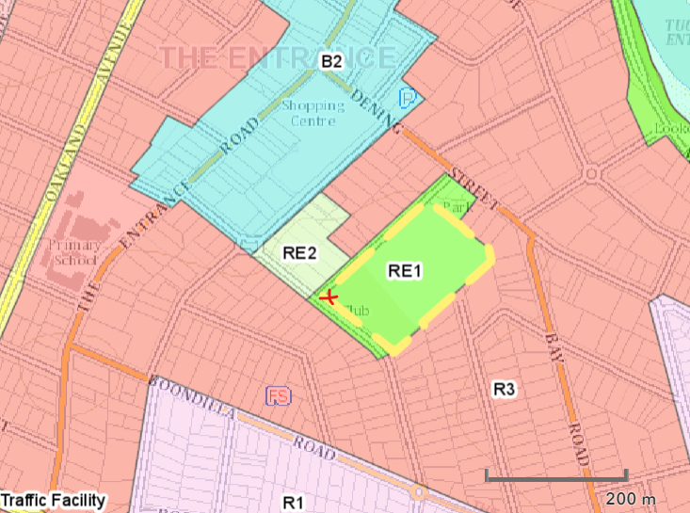

Above: Site (yellow) and LED plinth sign location (red) on the CCLEP 2022 zoning map.

Included below for your reference are the limitations that apply under Zone 3 and Zone 4 of the Transport Corridor Outdoor Advertising and Signage Guidelines 2017.

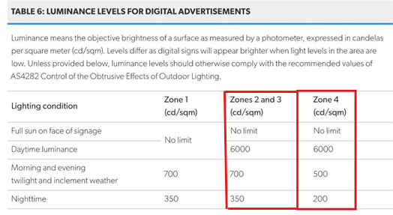

It is Council officer’s opinion that the site appears to be more characteristic of Zone 4 being more of a residential than commercial context.

Additionally, it is further noted that the TCOAS Guideline states *A consent authority may determine a site in a more sensitive zone if there’s sensitive land uses (ie. residential nearby) that maybe affected.*

The applicant has advised that the LED sign is capable of being dimmed/programmed to meet the requirements of either Zone 4 or 3 for different times of the day/night.

Conditions have been drafted for the Panel with the option for either Zone 3 or Zone 4 (under draft condition 6.2).

* ***Tree protection***

Tree protection conditions during works have been included.

* ***Reference to earlier consent granted for the carparking***

Draft condition 6.6 has been included which references the earlier consent granted for the car parking located on the separate lots at 21 Park Road and 10 Warrigal Street and which reads:

*6.6 The car parking for this development relies on the car parking approved under development consents 74/(105) and 77/(274) for 21 Park Road and 10 Warrigal Street.*